How to reset Windchill GPDM Password
- Please login to Windchill GPDM application.
URL - https://plm.wc.gpdm-euc1.fmcglobal.net/Windchill

- Navigate to Quick Links => My Settings => Profile.
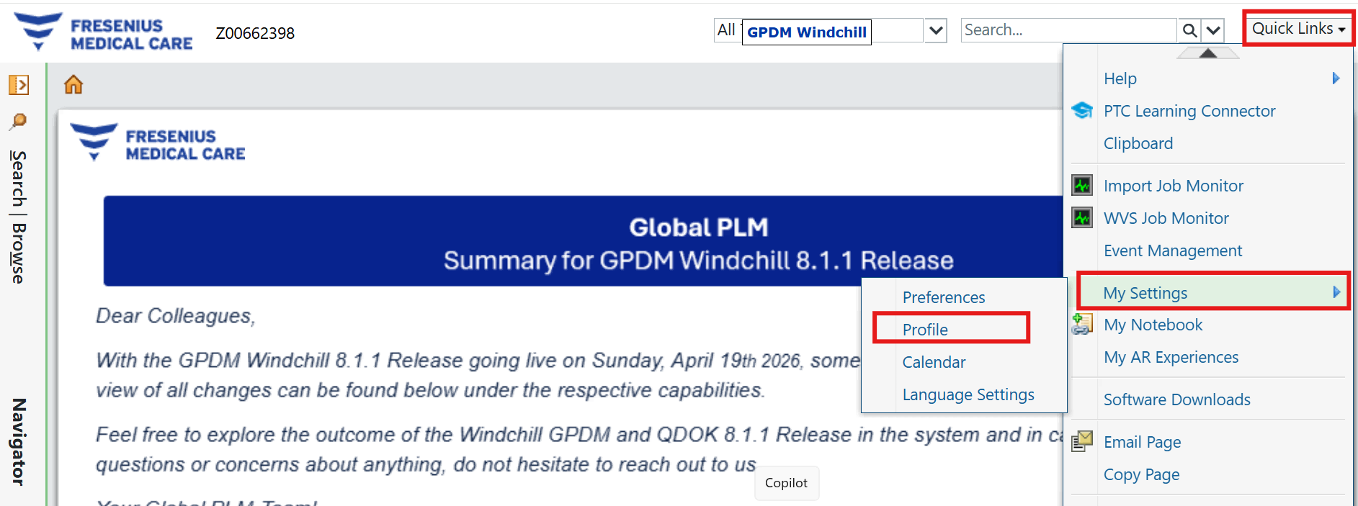

- Click on Action => Edit Password.
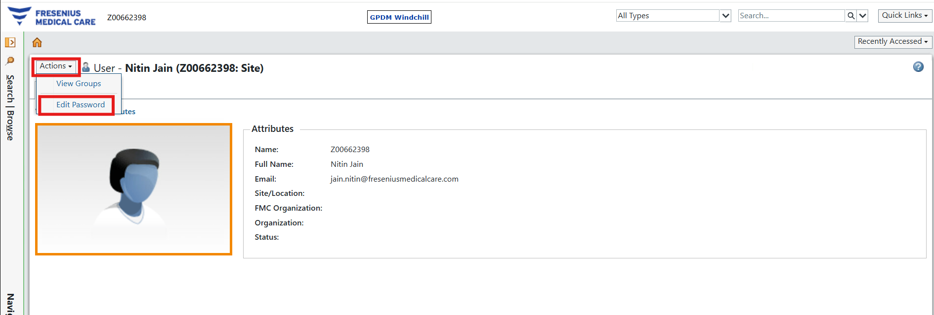

- New window will pop up as below, enter current and new password to change the password:
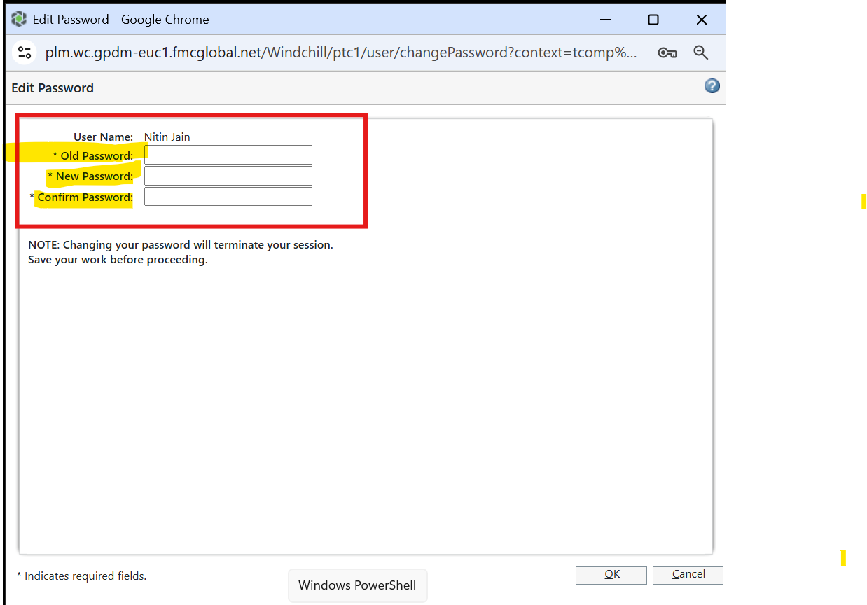

For Question/Issues: Please create a ticket from QuickService Help Center (https://qservice.intra.fmeone.com/servicedesk/customer/portals)

